**Measure of Dispersion:**

**In order to measure the distribution of the dataset, we can use the below 2 techniques.**

* Variance (σ2 )
* Standard Deviation ( $\text{σ})$**= $√variance$**

**Population variance:**

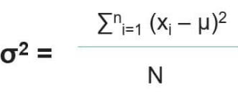

Sample variance:

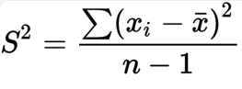

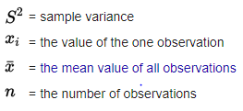

**Standard deviation** ($√variance$**) = $σ$**

It is used to measure the, How many distributions away from the mean.

Let us take the below example:

Mean

0.18 1.51 3 4.41 5.82

-1 +1

-2 +2

**Standard deviation:**

* How many standard deviations **4** away from the mean - +1
* How many standard deviations **3** away from the mean = 0
* How many standard deviations **2** away from the mean = -1

Hope you enjoyed this session.